Python 3.4.3

Installation

Download the latest archive, tar -xzf it, then cd in it, then type ./configure to start compiling, then make, then make install

Then access the pytohn console by typiing in python3.4 (exit with ctrl+D)

Here is a list of most of the commands used in py:
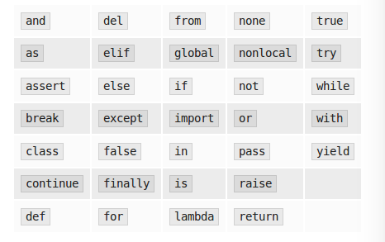
Creating a script

On linux, you need to specify, on the first line of the code, the path to the python interpreter in a comment (it's a standard procedure).
#!usr/bin/python3.4

Then specify the text encoding
# -*-coding:utf-8 -*

You might wanna chmod the script afterwards.

Testing the script

Open the terminal and open the file with the interpreter:
$ python3.4 script.py

Program that multiplies a number x times:
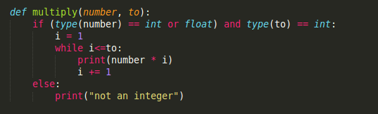

A library in python is called a module. Modules of the same type are gathered into folders called packages.

Importing

Here we put the previous funciton in a script called multiply.py and import it into our running script like so:

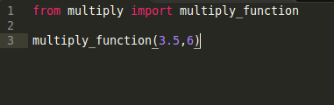
If we create a package in which we place the module multiply, it will then look like:
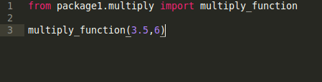
Notice the object like notation.

Usually, we put an init file called __init__.py in each package folder

Handling exceptions

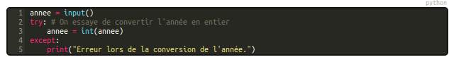
This way of doing things sucks. You need to be more specific, like so:

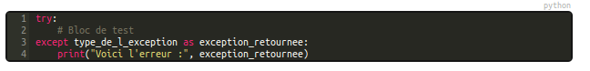
You can add a block “finally” to make code run notwithstanding wether there was an error or not
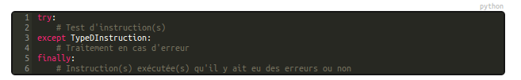
Here is our multiply function, but instead of if, we use try and assert

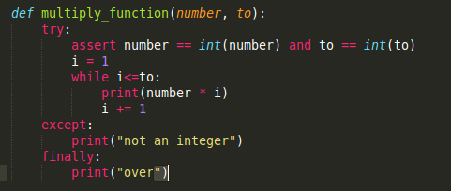
This is what it looks like in Ruby:
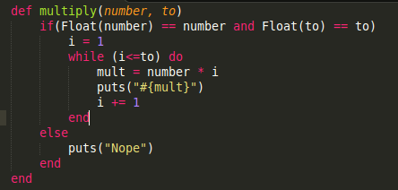
And this is the (worse) version in PHP:
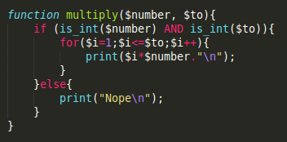

The main problem encountered in the casino exercise was verifying that the user inputs a correct amount for his bet (and checking that it was indeed a numerical value). Here is a solution using try and except

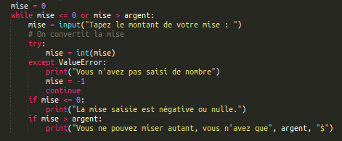
The except block, by setting mise to -1, redirects to the beginning of the loop.

OOP

ruby: “We are printing this #{variable1}, this #{one}, and #{that_one}” {variable1,one, that_one}

python:

Passing this into a function raises a problem: you don't know how many arguments will the format parameter take. You solve it like this:

“string”.split(“ “)
“ “.join(my_list)

There is a more efficient way of taking the x first even numbers from a list (cf casino)

Basically if you pass *parameter, python will think it's a list, if you pass **paramater, python will think it's a dictionnary

Objects

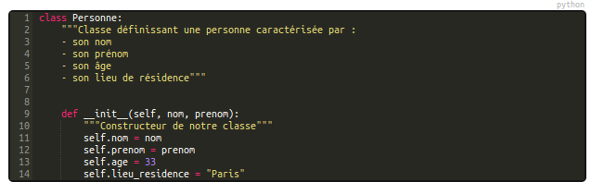
Instance variable: self.variable = value
Class variable: className.variable = value

In the same fashion, we can define class methods (then, instead of specifying self as a parameter, we will specify cls)

def compteur(cls):
print cls.class_variable

compteur = classmethod(compteur)

If you don't put self or cls, the method defined will be a static method. You still have to specify it afterwards though:

method = staticmethod(method)

note: don't use % anymore to fomrat strings, unse format() instead.

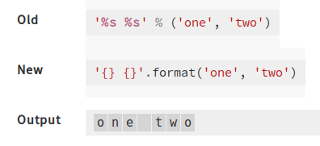

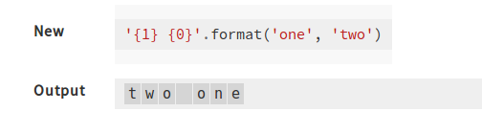

You can add padding left or right when you format strings:

“string {:>10}”.format('test')
=> string test

“{:10} string”.format('test')
=> test string

“{:_10} string”.format(“test”)
=> test________string

You can pass dictionnaries inside the method:

data = {“first” = 'Hodor', “last” = 'Hodor'}

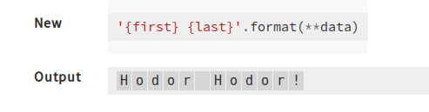
there is no notion of private and public in python. In order to set some variables to private, you must use proprieties. This means setting the variable in the init method as such (self._variable = value) and creating the property below (variable = property(self._set_variable, self._get_variable)

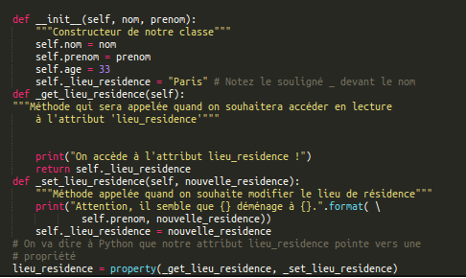
__repr__(self)

This method, with a simple return, customizes how the object will be displayed.
Def __repr__(self):
return 'nom{1}, prenom{2}'.format(self.nom, self.prenom)

=> repr(object1)
jacques, pierre

Special methods
These allow you to modify the behaviour of the script when processing certain mathematical operations (like allowing to automatically transform a given amount of seconds into min:sec)
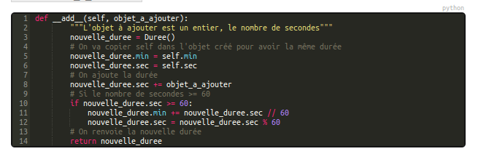

__iadd__ allows you to do that for += and -= operators.

To conclude, special methods are used for operator overloading

http://blog.teamtreehouse.com/operator-overloading-python

Sorting

There are two ways of sorting in python

First, the method .sort can act on strings and lists. It modifies the original object

Second, the function sorted() can act on any object type and you can specify which criteria it will take into account for the sorting. It creates a new object a leaves the original untouched.

ex: you want to sort the students by mean. Sorted() takes a second optional parameter key

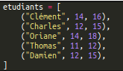

=> sorted(etudiants, key = lambda columns: columns[2])

If each student had been constructed as an object, you would access the third column with a method:

=> sorted(etudiants, key=lambda etudiant: etudiant.moyenne)

a quicker way is to use itemgetter() and attrgetter() from the operator library
=> sorted(etudiants, key = itemgetter(2))
these functions can take several parameters: you can sort by two or more criteria.

Object Inheritance

There is one thing to remember when creating a subclass.

If you have a class Personne

class Personne:
def _init_(self, nom, prenom):

And create a subclass SpecialAgent

class SpecialAgent(Personne):
def init(self, nom, prenom, matricule)

You will have to access the init method through the original class
class SpecialAgent(Personne):
def _init_(self,nom, prenom):
Personne._init_(self, nom,prenom)
self.matricule = matricule

Any class can inherit from several classes at once. The order in which python will look for methods is the order in which the over classes have been declared.

Custom Iterations

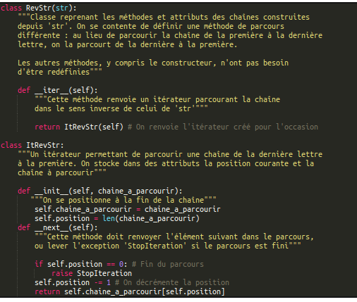
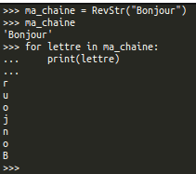
Generators

yield is like a return in loops
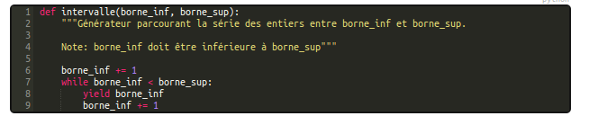
.close() allows you to interrupt a loop if something happens
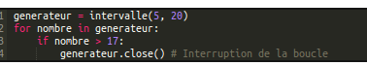
.send()
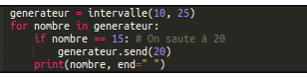
Used for example to skip a certain portion of numbers in a range

Decorators

a decorator is a way to customize or modify a pre-existing function without modifying the code of that function. It can be used to mesure the time of execution or things like that.

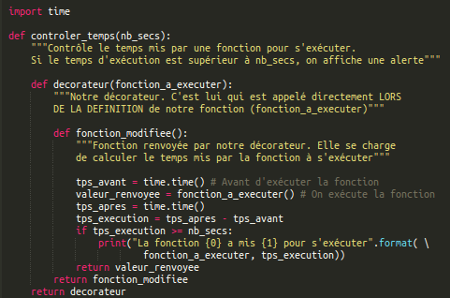
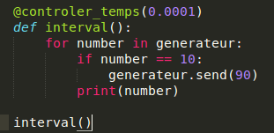
Another example of decorator are singletons. These decorators, when placed before the definition of a class, make sure that only one instance of it can be created

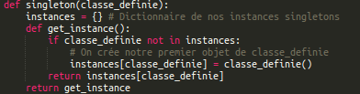
You can also create decorators that control the nature of the parameters passed to a functions

